ASSIGNMENT 1

Perform the following tasks in the Linux shell with the help of appropriate commands:

1. Check the manual for the ‘man’ command.

>> man man

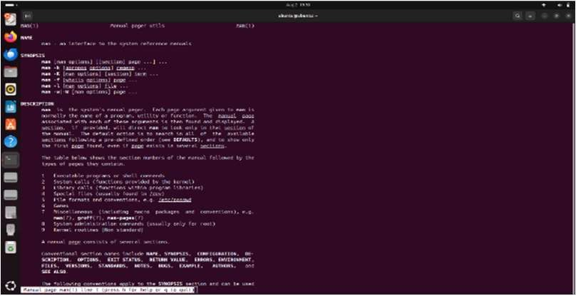

1. Display the current date and time.

>>date



1. Display the calendar of the current month.

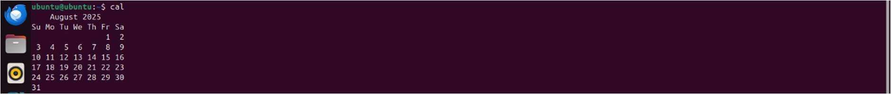>>cal

1. Display the current logged-in user.

>>whoami



1. Display more information about the current logged-in user.

>>id

1. Display the current working directory.

>>pwd



1. Check the contents of the current working directory.

>> ls



1. Make a new directory ‘Folder1’ in your current working directory.

>>mkdir Folder1

1. Enter the newly created directory Folder1 and go up one level.

>>cd Folder1

>>cd ..

1. Delete the newly created directory Folder1.

>>rmdir Folder1

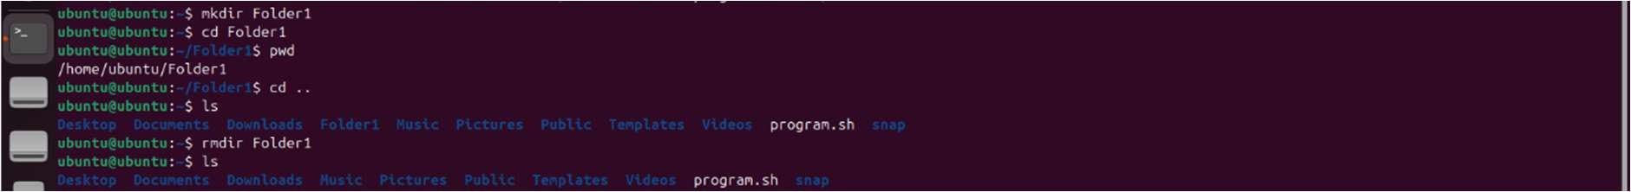

1. Concatenate 2 files and display the resulting content:
   * Create 2 new files, name them ‘File1.txt’ and ‘File2.txt’ respectively.
   * Write ‘Hello’ in File1.txt and ‘World!’ in File2.txt.
   * Concatenate these 2 files, display the content, and save the result in ‘File3.txt’.
   * Delete File2.txt. Now compare File1.txt and File3.txt.

>>echo ‘hello’>File1.txt

>>echo ‘world!’>File2.txt

>>cat File1.txt File2.txt>File3.txt

>>cat File3.txt

>>rm File2.txt

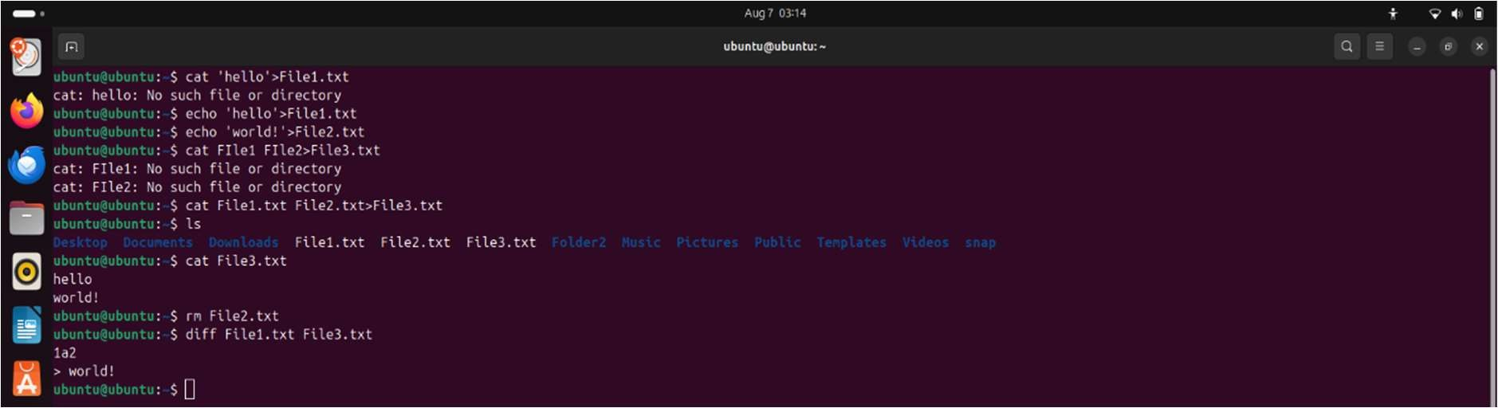>>diff File1.txt File3.txt

2

1. Check and display the word count in File3.txt.

>> wc File3.txt



1. Lexicographically sort the files and folders in the current working directory using the pipe operator along with other appropriate commands.

>> ls|sort

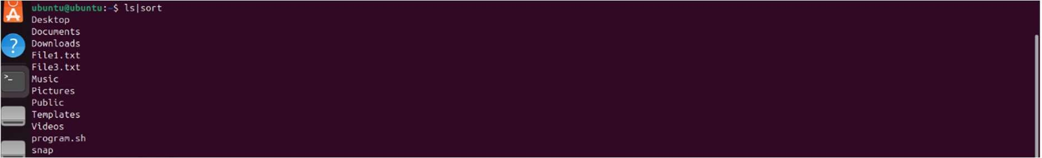

1. Make a new directory ‘Folder2’ in your current working directory. Copy and paste File3.txt into the aforementioned directory.

>>mkdir Folder2

>>cp File3.txt Folder2/



1. Check the read / write permission of File3.txt.

>>ls -l File3.txt



1. Set the following permissions for File1.txt:
   * File owner permission as read-only.
   * Group file owner permission as read and write.
   * Other user permission as read, write and execute.
   * All other system user permissions as read, write and execute.

>>chmod 467 File1.txt



3

ASSIGNMENT 2

1. Use the ‘ps’ command to perform the following operations:
   1. Display the process status of the current shell.
   2. Display the process status of all the running processes.
   3. Display the process status of all the running processes in a full format.
   4. Display the process status of all the running processes except session leader.
   5. View all the running processes.

>> ps $$



>> ps -e



>> ps -ef

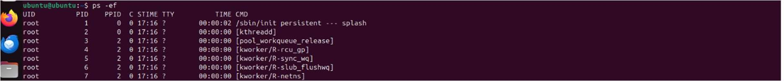

>> ps -e –no-headers --deselect



>>ps aux

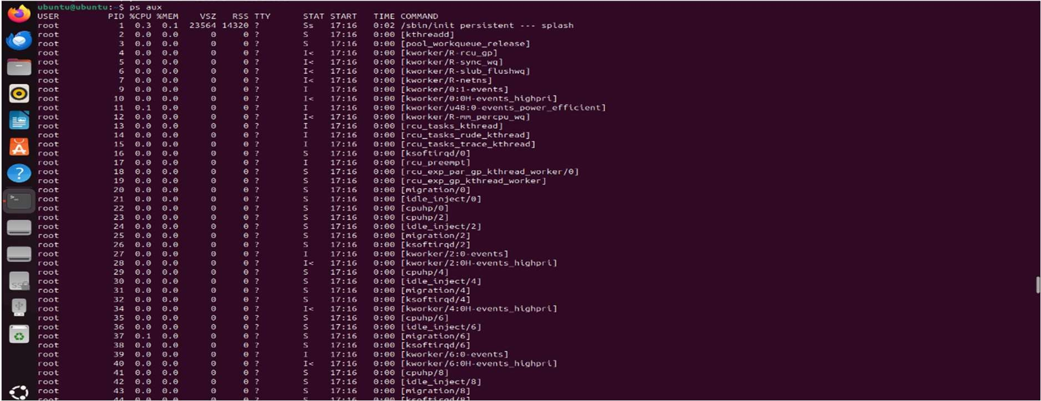

1. Open the Firefox browser. Now using the ‘htop’ program, display the following:
   1. The PID(s) of the Firefox process / processes.
   2. The owner of the process / processes.
   3. Virtual memory being consumed by the process / processes.
   4. The percentage of the processor time used by the process / processes.
   5. The percentage of physical RAM used by the process / processes.
   6. The name of the command that started the process / processes.

>>firefox &

>>htop

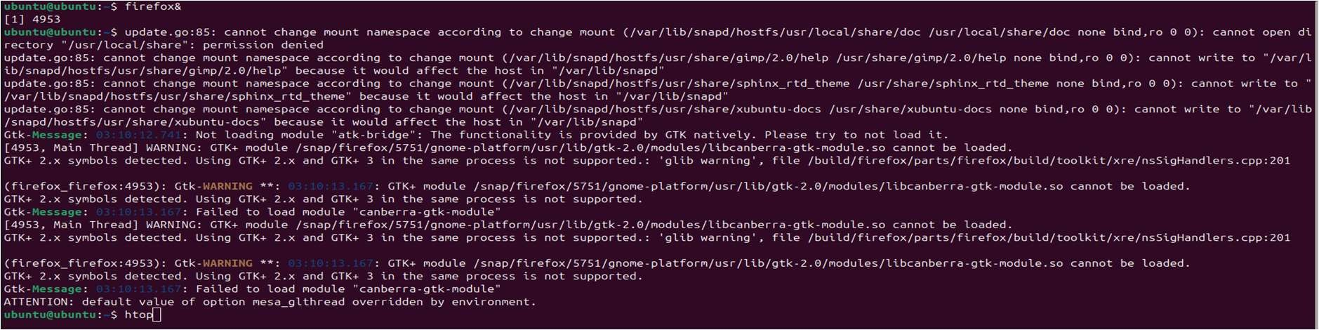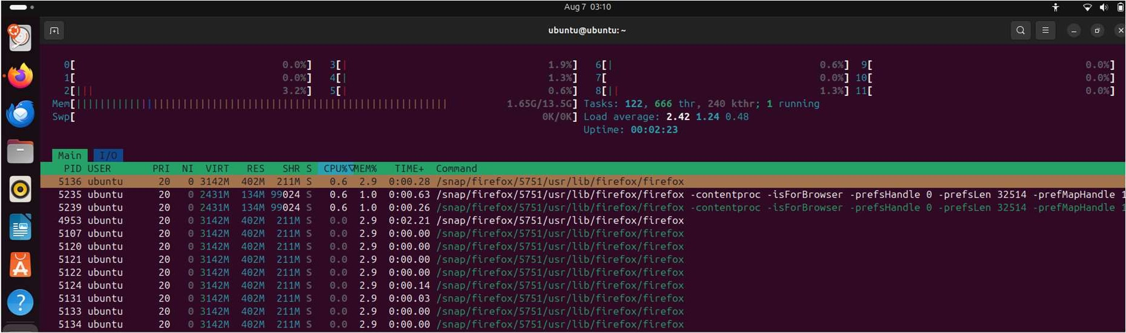

1. Kill a specific process by using its PID.

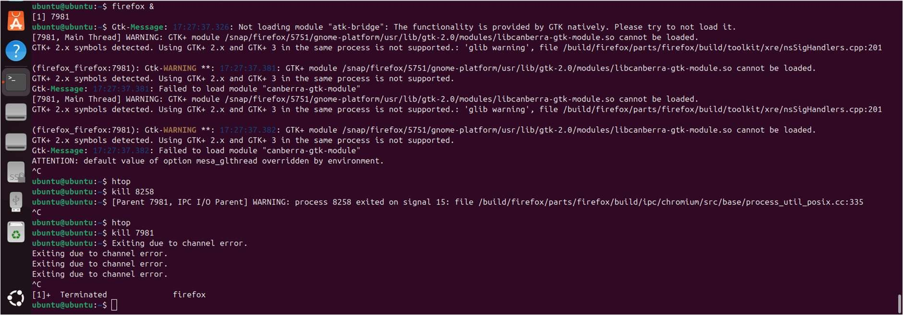>> kill <PID>

1. Kill all the processes in the system.

>> sudo kill -9 -1

1. Open the Firefox browser. Observe and state the following using appropriate commands:
   1. Parent process

>>ps -o pid

* 1. Child process / processes

>>pgrep -p 10023

* 1. PID of the associated processes

>>pidof firefox

* 1. PPID of the associated processes

>>ps -o ppid= -p $(pidof firefox)

* 1. TID of the associated processes

>>ps -L -p $(pidof firefox)

* 1. Kill a child process

>>kill10260

* 1. Kill the parent process

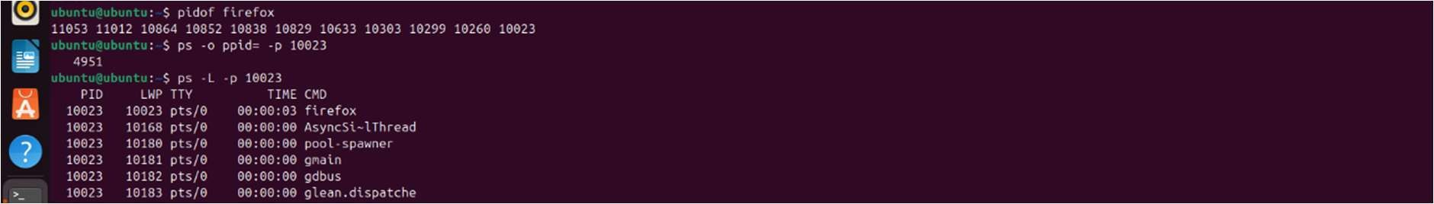>>kill 10023

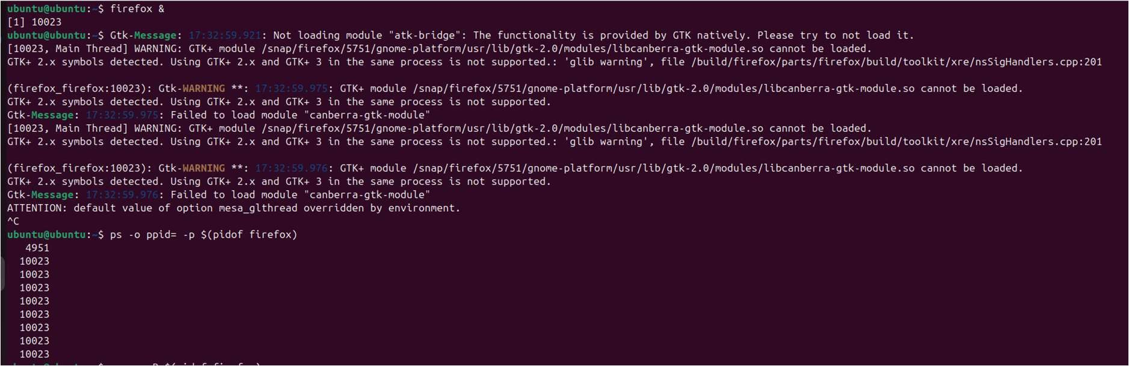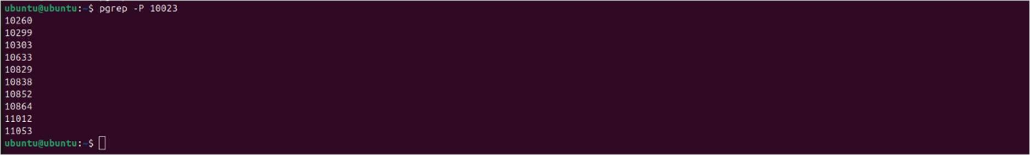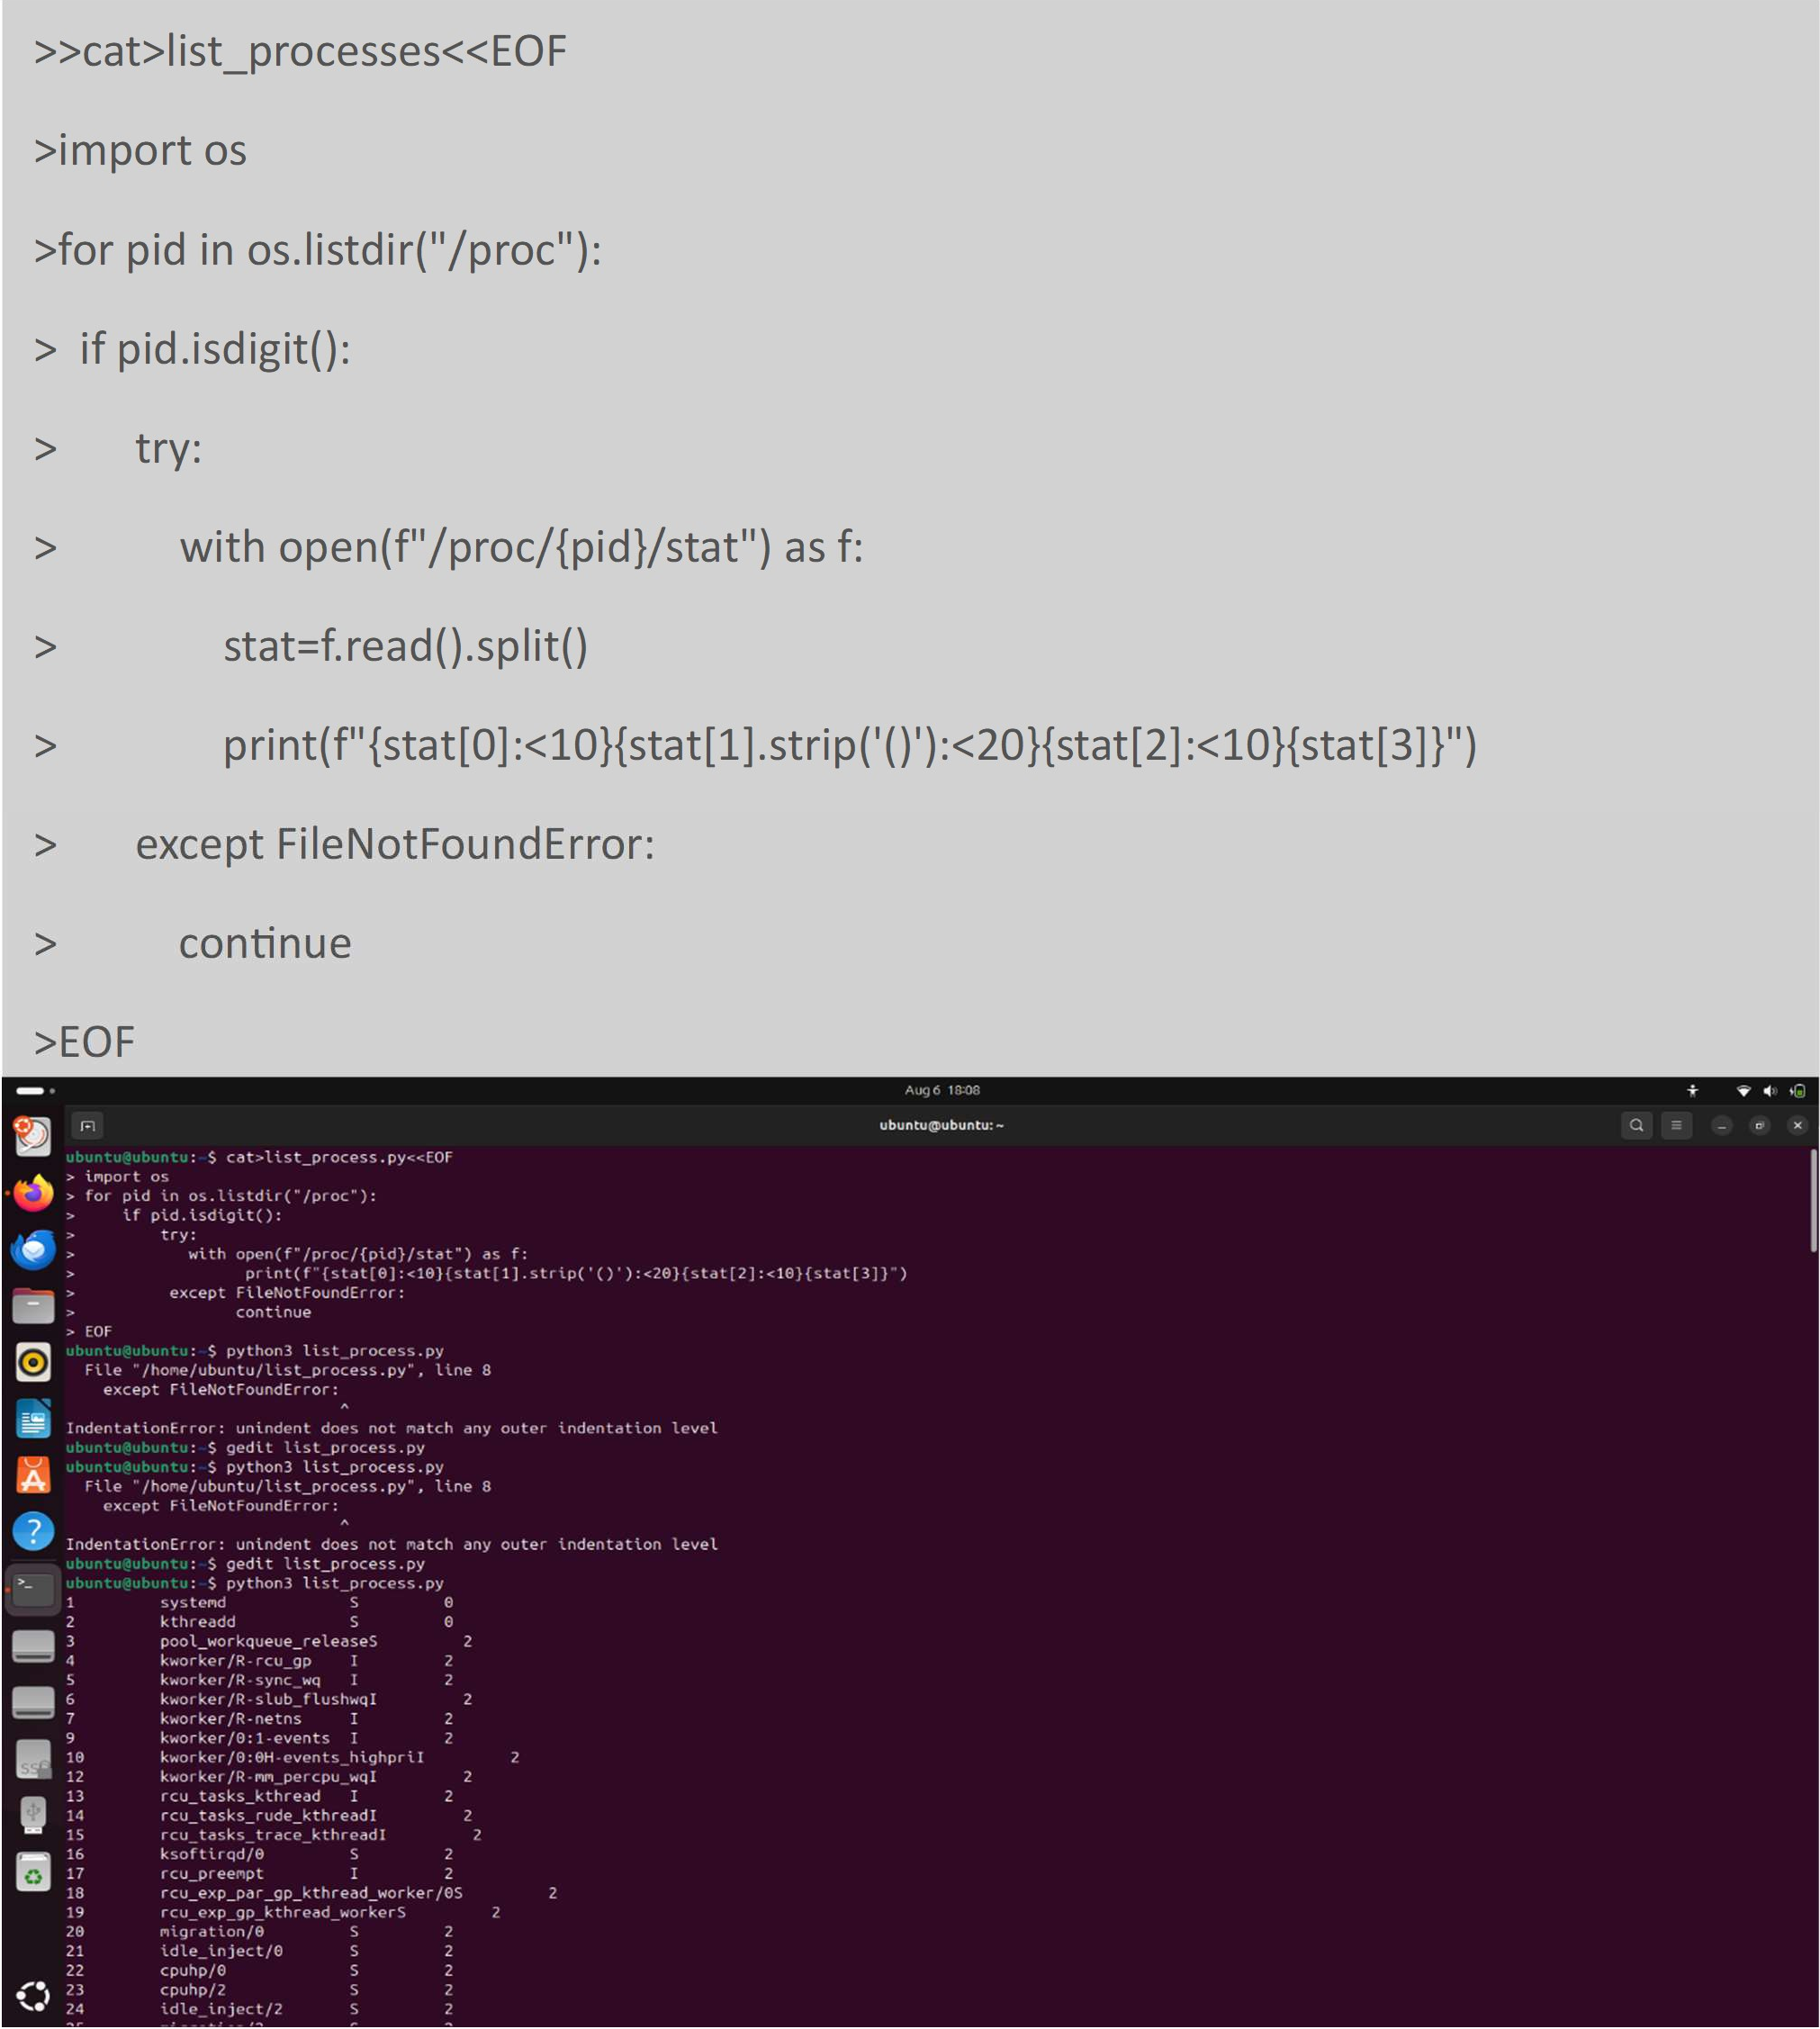

1. Using CAT command, write a program in Python to get a list of all the running processes.

>>cat>list_processes<<EOF

>import os

>for pid in os.listdir("/proc"):

* if pid.isdigit():
* try:
* with open(f"/proc/{pid}/stat") as f:
* stat=f.read().split()
* print(f"{stat[0]:<10}{stat[1].strip('()'):<20}{stat[2]:<10}{stat[3]}")
* except FileNotFoundError:
* continue

>EOF

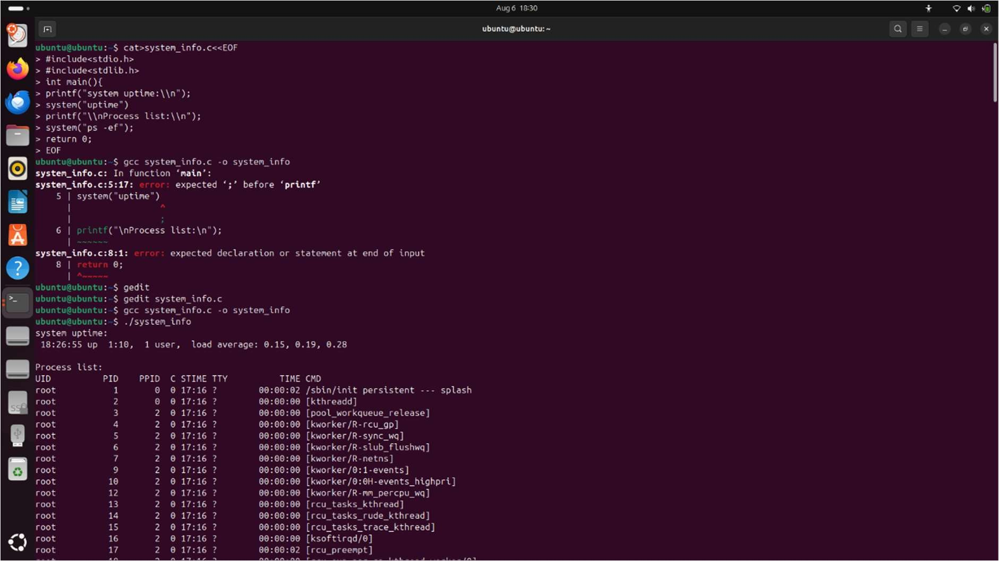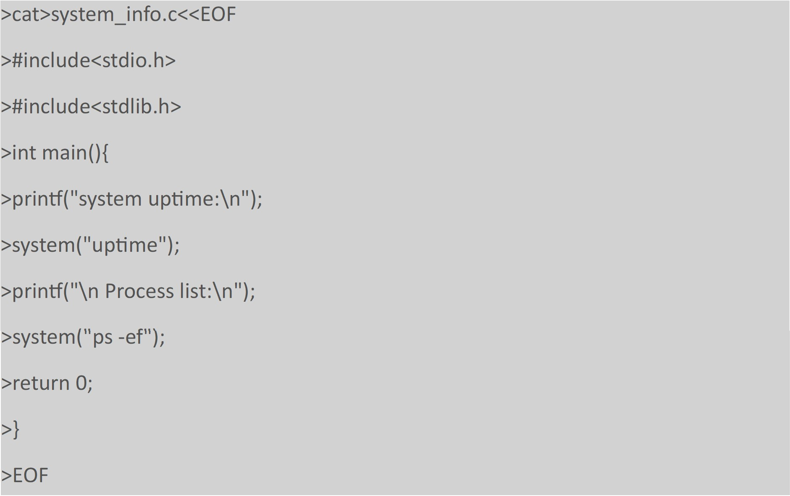

1. Using CAT command, write a program in C to get the system and process information.

>cat>system_info.c<<EOF

>#include<stdio.h>

>#include<stdlib.h>

>int main(){

>printf("system uptime:\n");

>system("uptime");

>printf("\n Process list:\n");

>system("ps -ef");

>return

ASSIGNMENT 4

FCFS

import matplotlib.pyplot as plt print("FIRST COME FIRST SERVE SCHEDULING")

def calculate_metrics(processes, n, bt): wt = [0] * n

tat = [0] * n rt = [0] * n

ct = [0] * n ct[0] = bt[0]

for i in range(1, n):

ct[i] = ct[i - 1] + bt[i]

for i in range(n):

tat[i] = ct[i] - processes[i][1]

wt[i] = tat[i] - processes[i][2] rt[i] = ct[i]

avg_tat = sum(tat) / n avg_wt = sum(wt) / n avg_rt = sum(rt) / n

return ct, tat, wt, rt, avg_tat, avg_wt, avg_rt

def main():

n = int(input("Enter the number of processes: ")) processes = []

for i in range(n):

arrival_time = int(input(f"Enter arrival time for process {i +

1}: ")) "))

burst_time = int(input(f"Enter burst time for process {i + 1}: processes.append((i + 1, arrival_time, burst_time))

processes.sort(key=lambda x: x[1])

burst_time_list = [process[2] for process in processes]

completion_time, turnaround_time, waiting_time, response_time, avg_turnaround_time, avg_waiting_time, avg_response_time = calculate_metrics(processes, n, burst_time_list)

print("\nProcess\tArrival Time\tBurst Time\tCompletion Time\tTurnaround Time\tWaiting Time\tResponse Time")

for i in range(n): print(f"P{i +

1}\t{processes[i][1]}\t\t{processes[i][2]}\t\t{completion_time[i]}\t\t{ turnaround_time[i]}\t\t{waiting_time[i]}\t\t{response_time[i]}")

print(f"\nAverage Turnaround Time: {avg_turnaround_time}") print(f"Average Waiting Time: {avg_waiting_time}") print(f"Average Response Time: {avg_response_time}")

'''plt.figure(figsize=(10, 4)) for i in range(n):

plt.barh(f'P{processes[i][0]}', completion_time[i] - processes[i][1], left=processes[i][1], color='tab:blue')

plt.xlabel('Time') plt.ylabel('Processes') plt.title('Gantt Chart (FCFS)')

plt.grid(True, linestyle='--', alpha=0.6) plt.show()'''

plt.figure(figsize=(10, 4)) plt.title("Gantt Chart - FCFS Scheduling")

for i in range(n):

plt.barh(y=0, width=burst_time_list[i], left=completion_time[i]

- burst_time_list[i], height=0.5)

plt.yticks([]) plt.xlabel("Time")

plt.show() main()

OUTPUT

FIRST COME FIRST SERVE SCHEDULING

Enter the number of processes: 3 Enter arrival time for process 1: 0 Enter burst time for process 1: 10 Enter arrival time for process 2: 1 Enter burst time for process 2: 5 Enter arrival time for process 3: 3 Enter burst time for process 3: 2

Process Arrival Time Burst Time Completion Time Turnaround Time Waiting Time Response Time

|  |  |  |  |  |  |
| --- | --- | --- | --- | --- | --- |
| P1 0 | 10 | 10 | 10 | 0 | 10 |
| P2 1 | 5 | 15 | 14 | 9 | 15 |
| P3 3 | 2 | 17 | 14 | 12 | 17 |

Average Turnaround Time: 12.666666666666666 Average Waiting Time: 7.0

Average Response Time: 14.0

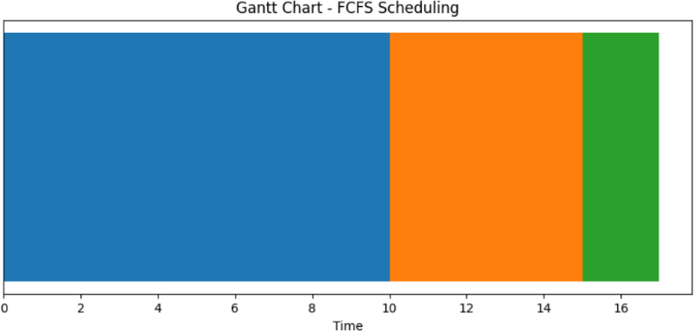

# SJF

import matplotlib.pyplot as plt

def findWaitingTime(processes, n, wt, ct, gantt_chart): rt = [0] * n

for i in range(n):

rt[i] = processes[i][2]

complete = 0

t = 0

min_rt = float('inf') short = 0

check = False

while complete != n: for j in range(n):

if processes[j][1] <= t and rt[j] < min_rt and rt[j] > 0: min_rt = rt[j]

short = j check = True

if not check: t += 1

continue

rt[short] -= 1 min_rt = rt[short]

if min_rt == 0:

min_rt = float('inf')

complete += 1 check = False ct[short] = t + 1

wt[short] = ct[short] - processes[short][1] - processes[short][2]

if wt[short] < 0: wt[short] = 0

gantt_chart.append((t, t + 1, processes[short][0])) t += 1

def findTurnAroundTime(processes, n, wt, tat): for i in range(n):

tat[i] = processes[i][2] + wt[i]

def findavgTime(processes, n): wt = [0] * n

tat = [0] * n ct = [0] * n gantt_chart = []

findWaitingTime(processes, n, wt, ct, gantt_chart) findTurnAroundTime(processes, n, wt, tat)

print("Processes\tArrival Time\tBurst Time\tCompletion Time\tWaiting Time\tTurn-Around Time")

total_wt = 0

total_tat = 0

for i in range(n): total_wt += wt[i] total_tat += tat[i]

print(f" {processes[i][0]}\t\t{processes[i][1]}\t\t{processes[ i][2]}\t\t{ct[i]}\t\t{wt[i]}\t\t{tat[i]}")

avg_wt = total_wt / n avg_tat = total_tat / n

print(f"\nAverage Waiting Time: {avg_wt:.5f}") print(f"Average Turnaround Time: {avg_tat:.5f}")

plot_gantt_chart(gantt_chart, n) def plot_gantt_chart(gantt_chart, n):

fig, gnt = plt.subplots()

gnt.set_ylim(0, n + 1) gnt.set_xlim(0, gantt_chart[-1][1] + 1)

gnt.set_xlabel('Time') gnt.set_ylabel('Processes')

unique_processes = list(set(process for _, _, process in gantt_chart))

unique_processes.sort()

gnt.set_yticks(unique_processes) gnt.set_yticklabels([f'P{process}' for process in

unique_processes])

for i in range(len(gantt_chart)): start, end, process = gantt_chart[i]

gnt.broken_barh([(start, end - start)], (process - 0.4, 0.8), facecolors=('tab:blue', 'tab:orange', 'tab:green', 'tab:red')[process % 4])

plt.title('Gantt Chart') plt.show()

def main():

n = int(input("Enter the number of processes: ")) processes = []

for i in range(n):

arrival_time = int(input(f"Enter arrival time for process {i +

1}: ")) "))

burst_time = int(input(f"Enter burst time for process {i + 1}: processes.append([i + 1, arrival_time, burst_time])

processes.sort(key=lambda x: x[1]) findavgTime(processes, n)

main()

# OUTPUT

Enter the number of processes: 4 Enter arrival time for process 1: 0 Enter burst time for process 1: 8 Enter arrival time for process 2: 1 Enter burst time for process 2: 4 Enter arrival time for process 3: 2 Enter burst time for process 3: 9 Enter arrival time for process 4: 3 Enter burst time for process 4: 5

Processes Arrival Time Burst Time Completion Time Waiting Time Turn-Around Time

|  |  |  |  |  |  |
| --- | --- | --- | --- | --- | --- |
| 1 | 0 | 8 | 17 | 9 | 17 |
| 2 | 1 | 4 | 5 | 0 | 4 |
| 3 | 2 | 9 | 26 | 15 | 24 |
| 4 | 3 | 5 | 10 | 2 | 7 |

Average Waiting Time: 6.50000 Average Turnaround Time: 13.00000

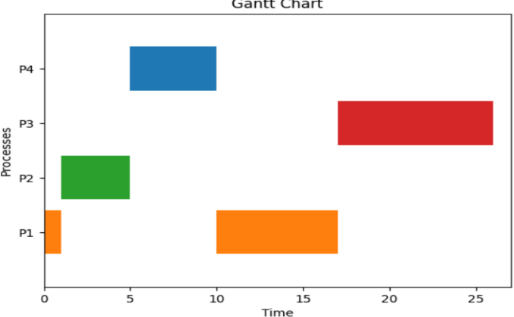

# SRTF

def calculate_metrics(processes): n = len(processes)

wt, tat, ct, rt = [0] * n, [0] * n, [0] * n, [0] * n

completed = [False] * n time = 0

for i in range(n): min_bt = float('inf') shortest = None

for j in range(n):

if not completed[j] and processes[j][1] <= time: if processes[j][2] < min_bt:

min_bt = processes[j][2] shortest = j

if shortest is None:

for j in range(n):

if not completed[j]:

time = processes[j][1] break

completed[shortest] = True

rt[shortest] = time - processes[shortest][1] time += processes[shortest][2]

ct[shortest] = time

tat[shortest] = ct[shortest] - processes[shortest][1] wt[shortest] = tat[shortest] - processes[shortest][2]

avg_tat = sum(tat) / n avg_wt = sum(wt) / n avg_rt = sum(rt) / n

return ct, tat, wt, rt, avg_tat, avg_wt, avg_rt def plot_gantt_chart(processes, ct):

fig, ax = plt.subplots(figsize=(10, 4))

sorted_processes = sorted(processes, key=lambda x: x[2]) for i, (pid, at, bt) in enumerate(sorted_processes):

start_time = max(at, ct[i - 1] if i > 0 else 0) ax.barh(f'P{pid}', left=start_time, width=bt, label=f'P{pid}') ct[i] = start_time + bt

ax.set_xlabel('Time')

ax.set_yticks([f'P{p[0]}' for p in sorted_processes]) ax.set_title('Gantt Chart')

plt.legend(loc='upper right') plt.show()

def main():

n = int(input("Enter the number of processes: "))

processes = [(i + 1, int(input(f"Arrival time for P{i + 1}: ")), int(input(f"Burst time for P{i + 1}: "))) for i in range(n)]

ct, tat, wt, rt, avg_tat, avg_wt, avg_rt = calculate_metrics(processes)

print("\nProcess\tArrival Time\tBurst Time\tCompletion Time\tTurnaround Time\tWaiting Time\tResponse Time")

for i in range(n):

pid, at, bt = processes[i] print(f"P{pid}\t{at}\t\t{bt}\t\t{ct[i]}\t\t{tat[i]}\t\t{wt[i]}\

t\t{rt[i]}")

print(f"\nAverage Turnaround Time: {avg_tat}") print(f"Average Waiting Time: {avg_wt}") print(f"Average Response Time: {avg_rt}") plot_gantt_chart(processes, ct)

main()

# OUTPUT

Enter the number of processes: 4

|  |  |  |  |  |  |  |
| --- | --- | --- | --- | --- | --- | --- |
| Arrival time for P1: Burst time for P1: 6 Arrival time for P2: Burst time for P2: 8 Arrival time for P3: Burst time for P3: 7 Arrival time for P4: Burst time for P4: 3 | | | 0  0  0  0 |  |  |  |
| Process  P1 | Arrival Waiting 0 | Time Time | Burst Time Response Time 6 | Completion  9 | Time Turnaround  9 | Time |
| 3 |
| P2 | 0 | 3 | 8 | 24 | 24 | 16 |
| P3 | 0 | 16 | 7 | 16 | 16 | 9 |
| P4 | 0 | 9 | 3 | 3 | 3 | 0 |
| 0 | | | |  |  |  |
| Average Turnaround Time: 13.0 | | | |  |  |  |

Average Waiting Time: 7.0 Average Response Time: 7.0

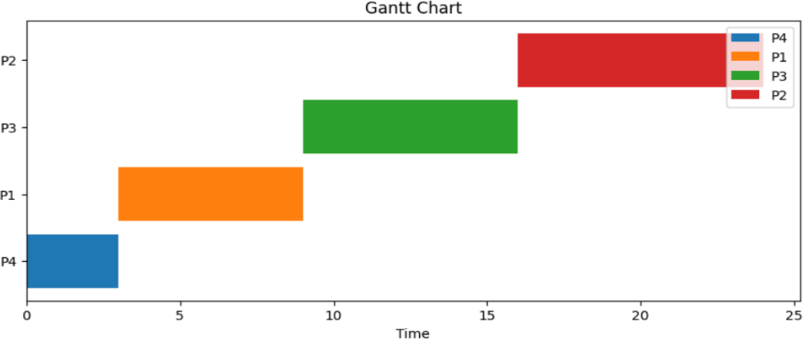

# ROUND ROBIN

import matplotlib.pyplot as plt

def round_robin(processes, burst_time, arrival_time, quantum):

n = len(processes) waiting_time = [0] * n turnaround_time = [0] * n

remaining_time = burst_time.copy() completion_time = [0] * n

time = 0 timeline = [] gantt_chart = []

while any(remaining_time): for i in range(n):

if remaining_time[i] > 0 and arrival_time[i] <= time: if remaining_time[i] > quantum:

timeline.append(processes[i]) gantt_chart.append(quantum) time += quantum remaining_time[i] -= quantum

else:

timeline.append(processes[i]) gantt_chart.append(remaining_time[i]) time += remaining_time[i] completion_time[i] = time waiting_time[i] = time - burst_time[i] -

arrival_time[i]

remaining_time[i] = 0

for i in range(n):

turnaround_time[i] = completion_time[i] - arrival_time[i]

avg_waiting_time = sum(waiting_time) / n avg_turnaround_time = sum(turnaround_time) / n

return avg_waiting_time, avg_turnaround_time, timeline, gantt_chart, completion_time, waiting_time, turnaround_time

def main():

n = int(input("Enter the number of processes: ")) processes = [f"P{i}" for i in range(n)]

arrival_time = [int(input(f"Enter arrival time for {processes[i]}: ")) for i in range(n)]

burst_time = [int(input(f"Enter burst time for {processes[i]}: ")) for i in range(n)]

quantum = int(input("Enter time quantum: "))

avg_waiting_time, avg_turnaround_time, timeline, gantt_chart, completion_time, waiting_time, turnaround_time = round_robin(processes, burst_time, arrival_time, quantum)

print("Process\tArrival Time\tBurst Time\tCompletion Time\tWaiting Time\tTurnaround Time")

for i in range(n): print(f"{processes[i]}\t\t{arrival_time[i]}\t\t{burst_time[i]}\

t\t{completion_time[i]}\t\t{waiting_time[i]}\t\t{turnaround_time[i]}")

print(f"\nAverage Waiting Time: {avg_waiting_time:.2f}") print(f"Average Turnaround Time: {avg_turnaround_time:.2f}")

plt.figure(figsize=(8, 3))

plt.bar(range(len(gantt_chart)), gantt_chart, tick_label=timeline) plt.xlabel('Time')

plt.ylabel('Burst Time')

plt.title(f'Round Robin Gantt Chart (Time Quantum = {quantum})') plt.show()

quantum_values = list(range(1, 11)) avg_waiting_times = []

for quantum_value in quantum_values:

avg_waiting_time , _, _, _, _, _, _ = round_robin(processes, burst_time, arrival_time, quantum_value)

avg_waiting_times.append(avg_waiting_time)

plt.figure(figsize=(8, 4))

plt.plot(quantum_values, avg_waiting_times, marker='o') plt.xlabel('Time Quantum')

plt.ylabel('Average Waiting Time')

plt.title('Average Waiting Time (AWT) vs. Time Quantum') plt.grid(True)

plt.show() avg_turnaround_times = []

for quantum_value in quantum_values:

_, avg_turnaround_time, _, _, _, _, _ = round_robin(processes, burst_time, arrival_time, quantum_value)

avg_turnaround_times.append(avg_turnaround_time)

plt.figure(figsize=(8, 4))

plt.plot(quantum_values, avg_turnaround_times, marker='x', color='orange')

plt.xlabel('Time Quantum') plt.ylabel('Average Turnaround Time')

plt.title('Average Turnaround Time (ATAT) vs. Time Quantum') plt.grid(True)

plt.show()

main()

# OUTPUT

Enter the number of processes: 4 Enter arrival time for P0: 0 Enter arrival time for P1: 1 Enter arrival time for P2: 2 Enter arrival time for P3: 4 Enter burst time for P0: 10 Enter burst time for P1: 5 Enter burst time for P2: 2 Enter burst time for P3: 8 Enter time quantum: 2

Process Arrival Time Burst Time Completion Time Waiting Time Turnaround Time

P0 0 10 25 15

25

P1 1 5 17 11

16

P2 2 2 6 2

4

P3 4 8 23 11

19

Average Waiting Time: 9.75 Average Turnaround Time: 16.00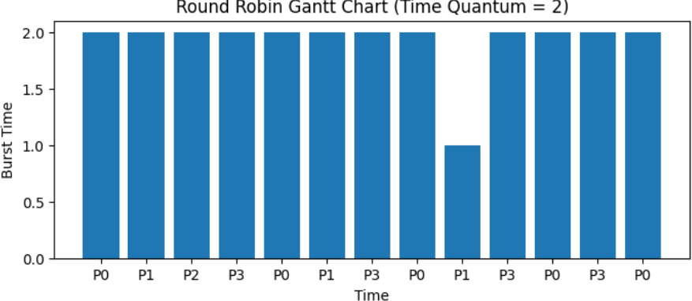

ASSIGNMENT 8

First Fit

from tabulate import tabulate

PDTm = [

    ["memory block no", "size", "status"],

    [0, 200, 1],

    [1, 100, 0],

    [10, 500, 0],

    [11, 200, 0],

    [100, 300, 0],

    [101, 600, 0],

]

print("Initial Memory Table (PDTm):")

print(tabulate(PDTm, headers="firstrow"))

print()

%pip install tabulate

PDTp = [

    ["process", "size"],

    ["P1", 210],

    ["P2", 410],

    ["P3", 110],

    ["P4", 420],

]

print("Process Table (PDTp):")

print(tabulate(PDTp, headers="firstrow"))

print()

unallocated_processes = []

allocated_mapping = {}

internal_frag = []

for process_index in range(1, len(PDTp)):

    process = PDTp[process_index]

    process_allocated = False

    for i in range(1, len(PDTm)):

        if PDTm[i][2] == 0 and PDTm[i][1] >= process[1]:

            PDTm[i][2] = 1

            allocated_mapping[PDTm[i][0]] = process[0]

            frag = PDTm[i][1] - process[1]

            if frag > 0:

                internal_frag.append([PDTm[i][0], frag])

            process_allocated = True

            break

    if not process_allocated:

        unallocated_processes.append(process)

print("\nCurrent PDTm:")

print(tabulate(PDTm, headers="firstrow"))

print("\nUnallocated processes:")

if unallocated_processes:

    print(tabulate(unallocated_processes, headers=["process", "size"]))

else:

    print("None — all processes were allocated.")

total_internal_frag = sum(frag[1] for frag in internal_frag)

print(f"\nTotal Internal Fragmentation: {total_internal_frag}")

external_frag = 0

if unallocated_processes:

    largest_unalloc_size = max(p[1] for p in unallocated_processes)

    for i in range(1, len(PDTm)):

        if PDTm[i][2] == 0 and PDTm[i][1] < largest_unalloc_size:

            external_frag += PDTm[i][1]

print(f"\nExternal Fragmentation: {external_frag}")

Initial Memory Table (PDTm):

memory block no size status

----------------- ------ --------

0 200 1

1 100 0

10 500 0

11 200 0

100 300 0

101 600 0

Process Table (PDTp):

process size

--------- ------

P1 210

P2 410

P3 110

P4 420

Current PDTm:

memory block no size status

----------------- ------ --------

0 200 1

1 100 0

10 500 1

11 200 1

100 300 0

101 600 1

Unallocated processes:

process size

--------- ------

P4 420

Total Internal Fragmentation: 570

External Fragmentation: 400

Best Fit

from tabulate import tabulate

PDTm = [

    ["memory block no", "size", "status"],

    [0, 200, 1],

    [1, 100, 0],

    [10, 500, 0],

    [11, 200, 0],

    [100, 300, 0],

    [101, 600, 0],

]

print("Initial Memory Table (PDTm):")

print(tabulate(PDTm, headers="firstrow"))

print()

PDTp = [

    ["process", "size"],

    ["P1", 210],

    ["P2", 410],

    ["P3", 110],

    ["P4", 420],

]

print("Process Table (PDTp):")

print(tabulate(PDTp, headers="firstrow"))

print()

unallocated_processes = []

allocated_mapping = {}

internal_frag = []

for process_index in range(1, len(PDTp)):

    process = PDTp[process_index]

    process_size = process[1]

    process_allocated = False

    best_index = -1

    best_size = float('inf')

    for i in range(1, len(PDTm)):

        if PDTm[i][2] == 0 and PDTm[i][1] >= process_size:

            if PDTm[i][1] < best_size:

                best_size = PDTm[i][1]

                best_index = i

    if best_index != -1:

        PDTm[best_index][2] = 1

        allocated_mapping[PDTm[best_index][0]] = process[0]

        frag = PDTm[best_index][1] - process_size

        if frag > 0:

            internal_frag.append([PDTm[best_index][0], frag])

        process_allocated = True

    else:

        unallocated_processes.append(process)

print("\nCurrent PDTm:")

print(tabulate(PDTm, headers="firstrow"))

print("\nProcess to Memory Block Mapping:")

if allocated_mapping:

    mapping_table = [[block, allocated_mapping[block]] for block in allocated_mapping]

    print(tabulate(mapping_table, headers=["Block No", "Allocated Process"]))

else:

    print("No allocations were made.")

print("\nUnallocated Processes:")

if unallocated_processes:

    print(tabulate(unallocated_processes, headers=["Process", "Size"]))

else:

    print("None — all processes were allocated.")

print("\nInternal Fragmentation per Block:")

if internal_frag:

    print(tabulate(internal_frag, headers=["Block No", "Internal Fragmentation"]))

else:

    print("None")

total_internal_frag = sum(frag[1] for frag in internal_frag)

print(f"\nTotal Internal Fragmentation: {total_internal_frag}")

external_frag = 0

if unallocated_processes:

    largest_unalloc_size = max(p[1] for p in unallocated_processes)

    for i in range(1, len(PDTm)):

        if PDTm[i][2] == 0 and PDTm[i][1] < largest_unalloc_size:

            external_frag += PDTm[i][1]

print(f"\nExternal Fragmentation: {external_frag}")

Initial Memory Table (PDTm):

memory block no size status

----------------- ------ --------

0 200 1

1 100 0

10 500 0

11 200 0

100 300 0

101 600 0

Process Table (PDTp):

process size

--------- ------

P1 210

P2 410

P3 110

P4 420

Memory allocation attempt complete (BEST-FIT).

Current PDTm:

memory block no size status

----------------- ------ --------

0 200 1

1 100 0

10 500 1

11 200 1

100 300 1

101 600 1

Process to Memory Block Mapping:

Block No Allocated Process

---------- -------------------

100 P1

10 P2

11 P3

101 P4

Unallocated Processes:

None — all processes were allocated.

Internal Fragmentation per Block:

Block No Internal Fragmentation

---------- ------------------------

100 90

10 90

11 90

101 180

Total Internal Fragmentation: 450

External Fragmentation: 0

from tabulate import tabulate

PDTm = [

    ["memory block no", "size", "status"],

    [0, 200, 1],

    [1, 100, 0],

    [10, 500, 0],

    [11, 200, 0],

    [100, 300, 0],

    [101, 600, 0],

]

print("Initial Memory Table (PDTm):")

print(tabulate(PDTm, headers="firstrow"))

print()

PDTp = [

    ["process", "size"],

    ["P1", 210],

    ["P2", 410],

    ["P3", 110],

    ["P4", 420],

]

Worse Fit

print("Process Table (PDTp):")

print(tabulate(PDTp, headers="firstrow"))

print()

unallocated_processes = []

allocated_mapping = {}

internal_frag = []

for process_index in range(1, len(PDTp)):

    process = PDTp[process_index]

    process_size = process[1]

    process_allocated = False

    worst_index = -1

    worst_size = -1

    for i in range(1, len(PDTm)):

        if PDTm[i][2] == 0 and PDTm[i][1] >= process_size:

            if PDTm[i][1] > worst_size:

                worst_size = PDTm[i][1]

                worst_index = i

    if worst_index != -1:

        PDTm[worst_index][2] = 1

        allocated_mapping[PDTm[worst_index][0]] = process[0]

        frag = PDTm[worst_index][1] - process_size

        if frag > 0:

            internal_frag.append([PDTm[worst_index][0], frag])

        process_allocated = True

    else:

        unallocated_processes.append(process)

print("\nCurrent PDTm:")

print(tabulate(PDTm, headers="firstrow"))

print("\nUnallocated Processes:")

if unallocated_processes:

    print(tabulate(unallocated_processes, headers=["Process", "Size"]))

else:

    print("None — all processes were allocated.")

total_internal_frag = sum(frag[1] for frag in internal_frag)

print(f"\nTotal Internal Fragmentation: {total_internal_frag}")

external_frag = 0

if unallocated_processes:

    largest_unalloc_size = max(p[1] for p in unallocated_processes)

    for i in range(1, len(PDTm)):

        if PDTm[i][2] == 0 and PDTm[i][1] < largest_unalloc_size:

            external_frag += PDTm[i][1]

print(f"\nExternal Fragmentation: {external_frag}")

Initial Memory Table (PDTm):

memory block no size status

----------------- ------ --------

0 200 1

1 100 0

10 500 0

11 200 0

100 300 0

101 600 0

Process Table (PDTp):

process size

--------- ------

P1 210

P2 410

P3 110

P4 420

Current PDTm:

memory block no size status

----------------- ------ --------

0 200 1

1 100 0

10 500 1

11 200 0

100 300 1

101 600 1

Unallocated Processes:

Process Size

--------- ------

P4 420

Total Internal Fragmentation: 670

External Fragmentation: 300